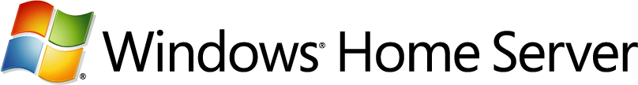

**Technical Brief**

**Windows Home Server Drive Extender**

Microsoft Corporation

Published: August 2008

Version: 1.1

**Abstract**

This technical brief provides an in-depth look at the features and functionality of Windows® Home Server Drive Extender. The brief has been updated to include additional information for Windows Home Server Power Pack 1.

To learn more about other aspects of WindowsHome Server, see the [Microsoft Web site](http://go.microsoft.com/fwlink/?LinkId=100260) (http://go.microsoft.com/fwlink/?LinkId=100260).



*The information contained in this document represents the current view of Microsoft Corporation on the issues discussed as of the date of publication. Because Microsoft must respond to changing market conditions, it should not be interpreted to be a commitment on the part of Microsoft, and Microsoft cannot guarantee the accuracy of any information presented after the date of publication.*

*This Technical Brief is for informational purposes only. MICROSOFT MAKES NO WARRANTIES, EXPRESS, IMPLIED OR STATUTORY, AS TO THE INFORMATION IN THIS DOCUMENT.*

*Complying with all applicable copyright laws is the responsibility of the user. Without limiting the rights under copyright, no part of this document may be reproduced, stored in or introduced into a retrieval system, or transmitted in any form or by any means (electronic, mechanical, photocopying, recording, or otherwise), or for any purpose, without the express written permission of Microsoft Corporation.*

*Microsoft may have patents, patent applications, trademarks, copyrights, or other intellectual property rights covering subject matter in this document. Except as expressly provided in any written license agreement from Microsoft, the furnishing of this document does not give you any license to these patents, trademarks, copyrights, or other intellectual property.*

*Unless otherwise noted, the companies, organizations, products, domain names, e-mail addresses, logos, people, places, and events depicted in examples herein are fictitious. No association with any real company, organization, product, domain name, e-mail address, logo, person, place, or event is intended or should be inferred.*

*© 2008 Microsoft Corporation. All rights reserved.*

*Microsoft, ActiveX, Windows, Windows Server, and Windows Vista are trademarks of the Microsoft group of companies.*

*UPnP is a certification mark of the UPnP Implementers Corporation.*

*All other trademarks are property of their respective owners.*

**Contents**

[Windows Home Server Drive Extender 4](#_Toc205267447)

[Features and Functionality 4](#_Toc205267448)

[Benefits 5](#_Toc205267449)

[Drive Extender In-Depth 6](#_Toc205267450)

[Windows Home Server Console 6](#_Toc205267451)

[Removing Hard Drives 7](#_Toc205267452)

[Hard Drive Partitioning 9](#_Toc205267453)

[Shared Folder Duplication 10](#_Toc205267454)

[Drive Extender Filter and Migrator Service 12](#_Toc205267455)

[The Magic of Tombstones 14](#_Toc205267456)

[Balancing Storage 15](#_Toc205267457)

[NTFS and Drive Extender 16](#_Toc205267458)

[Unhealthy and Missing Hard Drives 18](#_Toc205267459)

[File Conflict Notifications 19](#_Toc205267460)

[Additional Tips 20](#_Toc205267461)

[Viewing Orphan Shadow Files 20](#_Toc205267462)

[Disabling Volume ShadowCopy Services 21](#_Toc205267463)

[More Information 22](#_Toc205267464)

# Windows Home Server Drive Extender

Windows® Home Server Drive Extender is a new storage technology that enables you to use internal and external hard drives for additional storage on your home server. In addition, you can enable Folder Duplication for specific shared folders on their home servers. Maintaining two copies of a shared folder on separate hard drives helps protect against the failure of a single hard drive.

## Features and Functionality

The core features of Windows Home Server Drive Extender are:

• **Predefined Shared Folders**

Your home server is preconfigured with shared folders named Photos, Music, Videos, Public, and Software. From the Windows Home Server Console you can specify user permissions for these folders and create new shared folders. You can easily move files and folders from your home computers into the shared folders on your home server by using a drag-and-drop operation.

• **Easy to add more storage**

From the WindowsHome Server Console, you can add a new hard drive to your home server by following a simple wizard. The amount of storage available to your shared folders and home computer backups increases proportionally. The hard drives you add can be either internal or external (for example, USB 2.0 or FireWire).

• **Shared Folder duplication**

If you have two or more hard drives on your home server, Windows Home Server helps protect against hard drive failures by ensuring that files stored in shared folders are automatically duplicated to multiple hard drives.

## Benefits

Windows Home Server Drive Extender offers the following benefits for storage solutions. Some of the benefits are:

• **Allows the seamless addition of more hard drives**

As you add more hard drives to your home server, they are treated as a single large pool of available storage space. You no longer need to deal with drive letters (such as E:, F:, and G: ) because you can add more hard drives.

* **Works with internal and external hard drives**

You can add internal or external (for example, USB 2.0 or FireWire) hard drives to your home server to increase the available storage.

* **Shared Folder Duplication**

Windows Home Server Drive Extender supports reliability by duplicating designated shared folders. Important data is stored on separate hard drives, which provides protection against hard-drive failure. Duplication is configurable for every shared folder—so a shared folder can have multiple copies with each copy stored on a separate hard drive.

* **Makes hard drives and their content easy to move**

It is easy to remove outdated hard drives. You can store the content on other hard drives in the system and remove old or small hard drives.

Windows Home Server Drive Extender is different than and more powerful than a redundant array of independent disks (RAID) in several ways:

* You can use any hard drive, any time. You are not restricted to adding more hard drives of the same type and size. When you want to grow your home server storage, you can buy and add any hard drive you like.
* Internal and external hard drives can be used to grow your storage. No space in your home computer case? No problem—plug in one or more hard drives of your choice.
* Drive removal is easy. After you have had your home server for awhile, you may want to remove older, smaller hard drives and add new, larger hard drives so that you can store more files.

# Drive Extender In-Depth

This section explains how Windows Home Server Drive Extender works.

## Windows Home Server Console

The Windows Home Server Console enables you to configure the server storage and shared folders on your home server. The **Server Storage** tab allows you to view, add, and remove hard drives on your home server. You can see the status of your server storage, and attempt to repair hard drives that show a status of **Unhealthy**. You can also see a graphical representation of the total disk-space usage on your home server.

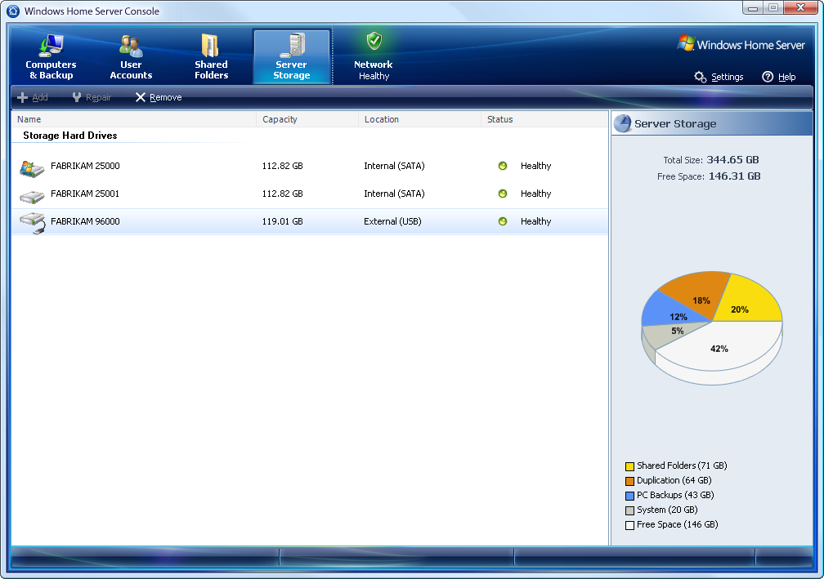From the Windows Home Server Console you can add a new hard drive to your home server by following a simple wizard. The amount of storage available to your shared folders and home computer backups increases proportionally. The hard drives you add can be internal or external (for example, USB 2.0 or FireWire).

|  |  |
| --- | --- |
| caution_ddCaution  Hard drives are formatted before they are added to server storage. Make sure that you back up any important files that are on the hard drive before you add it to server storage. Formatting a hard drive deletes all files on the hard drive.  note_ddNote  Do not use USB 1.1. USB 1.1 is much slower than USB 2.0. The home server performs slowly if you connect hard drives to a USB 1.1 port. If you are using external hard drives, ensure that they are connected through USB 2.0 or IEEE 1394 (for example, FireWire). USB 2.0 works best with one drive per controller. Performance suffers if multiple hard drives are connected to a single USB 2.0 controller. Using hubs to connect multiple USB drives to a single controller has a negative impact on system performance and is not recommended. |  |

The Server Storage pie chart shows the space used by Shared Folders, duplication of selected Shared Folders, the Home Computer Backup database, and System files. The amount of space taken up by ‘System’ in the pie chart includes volume shadow copies, files and folders in the Recycle Bin, as well as any files which are stored on a home server outside of the Shared Folders or application folders.

important_ddImportant

There is no reason for files to end up in the Recycle Bin of your home server, unless you are inappropriately using your home server with a monitor, mouse and keyboard attached. All administrative access to your home server should be done from a home computer using the Windows Home Server Console.

## Removing Hard Drives

If you want to remove a hard drive, there must be sufficient storage space on your home server so that the data and files can be duplicated to the hard drive before you physically remove it from your home server system. If there is not enough storage space, you will lose file duplication for some shared folders or lose some files. The home server will provide adequate warnings to prevent you from losing files.

note_ddNote

A best practice is to add a new larger hard drive to your home server, prior to removing an older hard drive with less disk space. This usually ensures that there will be adequate space to move the files off of the older hard drive due to the free space on the new larger hard drive.

Be sure to use the Windows Home Server Console to tell your home server that you want to remove your hard drive prior to physically removing it from your home server. The Remove a Hard Disk Wizard will list the files which your home server was not able to move off of the hard drive being removed. The reason for the failure is also noted in a details page which appears at the end of the wizard.

The process of removing a hard drive takes time, so plan the removal when no one needs access to your home server.

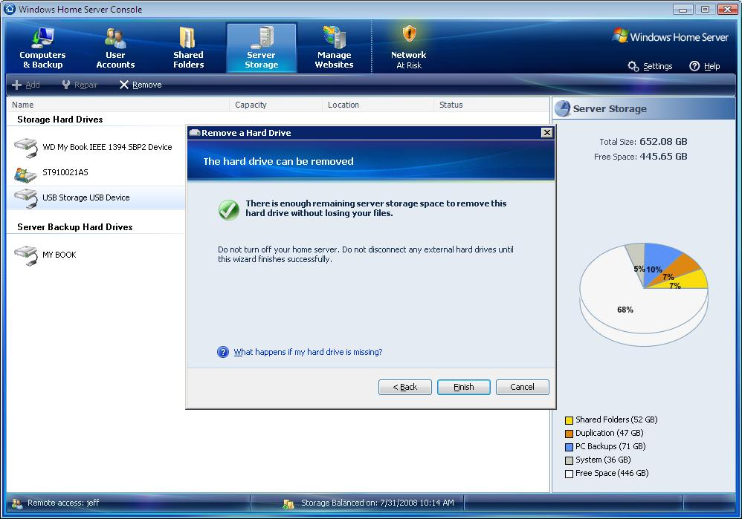

important_ddImportant

If you unplug an external hard drive prior to using the Windows Home Server Console to remove it, the drive will be listed as Missing. In this case, you should immediately plug the hard drive back into your home server, and then follow the instructions in the Remove a Hard Drive Wizard to safely remove it.

## Hard Drive Partitioning

In a single hard-drive system, Windows Home Server is configured with a 20-gigabyte system partition for the Windows Home Server operating system, and the remainder of the primary hard drive is allocated to the primary data partition. Each subsequent (or secondary) hard drive is logically added to the data partition. It appears to the user as one large hard drive; however, these drives are considered to be part of the secondary data partition. In reality, your home server consists of multiple hard drives of varying sizes.

The primary data partition is used to store a unique entry for each file. If a home server has more than one hard drive, these files become “tombstones.” Tombstones are NTFS file system reparse points that Windows Home Server Drive Extender understands. They are tiny files that redirect to one or two “shadow” files on the hard drives that make up the secondary data partition. The shadow files are where your data is really stored. If folder duplication is enabled for a Shared Folder, there will be two shadow files. If duplication is Off, there will be one shadow file.

note_ddNote

The primary data partition in a home server should be as large as possible for two reasons:

* You want to provide sufficient space to grow the file table for all of the files that you will store on your home server.
* Windows Vista® and other home computer operating systems check to see if there is adequate space on the primary data partition prior to starting a copy operation.

You can add additional internal and external hard drives to your home server if you need more storage space for your folders and files. There is no need to use equal capacity hard drives—WindowsHome Server will add the additional capacity of the new hard drive to the available storage on your home server.

caution_ddCaution

It is highly recommended that you not use hardware RAID technologies for your home server. Recovering from hard-drive failures becomes increasingly complex when hardware RAID systems are used. The recommended and supported approach is to use multiple hard drives that are configured as Just a Bunch of Disks (JBOD).

## Shared Folder Duplication

If your home server has multiple hard drives, WindowsHome Server Drive Extender will automatically choose a hard drive to store the files. You do not have to configure or manage this. In addition, if you have multiple hard drives, Windows Home Server helps provide protection against hard-drive failures by ensuring that files stored in shared folders are automatically duplicated across multiple hard drives. Duplication is configurable per shared folder, so a given shared folder can have two copies, with each copy stored on a separate hard drive.

note_ddNote

Shared folders can be marked **Unhealthy** if there is insufficient disk space for folder duplication to succeed. If you are running low on storage space, you can temporarily disable **Folder Duplication** on one or more of your shared folders until you add a new hard drive to your home server.

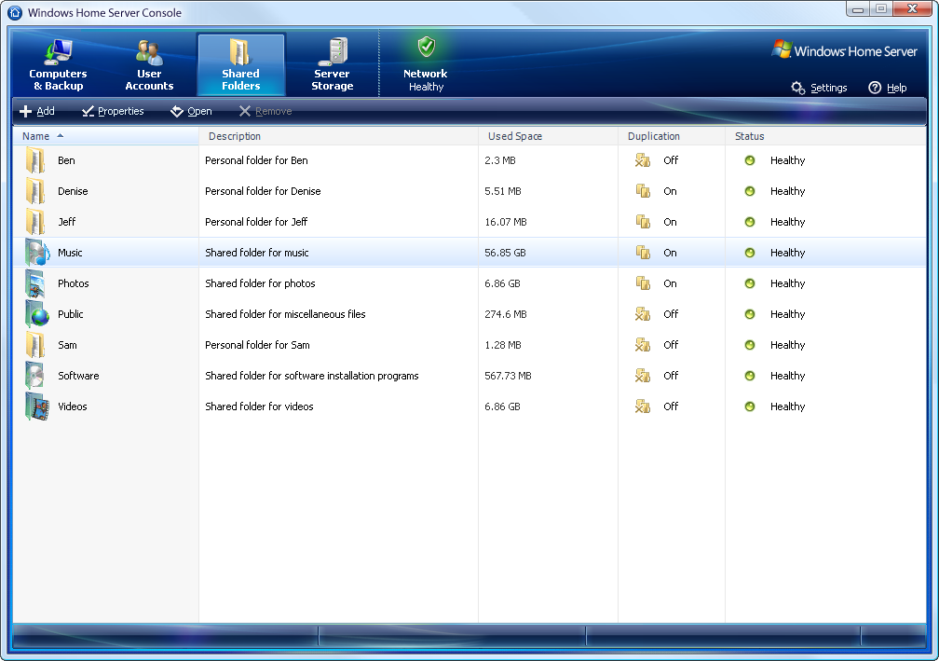

When you display the properties of a shared folder on the Shared Folders tab, the size displayed does not include duplicates if the Enable Folder Duplication check box is selected. However, the pie chart that is displayed from the Server Storage tab includes a figure for space that the shared folders consume and a figure for shared folder duplication.

caution_ddCaution

Windows Home Server automatically manages the shared folders on your home server. Do not modify the underlying configuration of the shared folders that Windows Home Server manages. Creating shared folders or changing the access permissions outside of the Windows Home Server Console is not supported and may cause future system updates to fail.

To highlight how this works, consider this example. If a new photo is saved to the **Photos** shared folder on your home server, the following happens:

1. A new entry for this file is created in the file table on the primary data partition. On a home server with multiple hard drives, this is a “tombstone” file.
2. The Windows Home Server Drive Extender file system filter creates a pointer (reparse point) for the new file and determines onto which hard drive the photo should be stored. The tombstone is updated with the location of the actual file. This file is known as the “master or primary shadow.”
3. If **Folder Duplication** is enabled for the **Photos** shared folder, the Windows Home Server Drive Extender migrator service creates a duplicate copy of the file and updates the tombstone file on the primary data partition with the reparse point to include the second location of the shadow file. This file is known as the “alternate or secondary shadow.”

important_ddImportant

If **Folder Duplication** is enabled, a shared folder may be marked as **Unhealthy** if there is not enough room to store two copies of the shared folder contents on different hard drives. There must be two hard drives with enough space to store the contents of the shared folder.

caution_ddCaution

You can lose files if you remove a hard drive. To safely remove a hard drive, click the **Server Storage** tab on the Windows Home Server Console. If you do not have enough server storage space, Windows Home Server warns you that you could lose files or file duplication as a consequence of removing the hard drive.

## Drive Extender Filter and Migrator Service

Windows Home Server Drive Extender creates the illusion of having a very large primary data partition by migrating files to one or more secondary data partitions. To complete the illusion, Windows Home Server Drive Extender leaves a “tombstone” file on the primary data partition, so that the user still sees the file in its original location. For example, even though Sample.jpg is not really taking up space on the primary data partition, it shows up if you type “dir” at a command prompt or open Windows Explorer from the primary data partition. These tombstones effectively act as symbolic links to the shadow files.

important_ddImportant

If you want to access files in shared folders, always access them through the shared folder name (\\server\SharedFolderName or \\localhost\SharedFolderName). If you browse the file system through administrator's desktop, you will discover multiple places where you might think your data is stored, but your data is likely stored elsewhere. Accessing \\server\SharedFolderName or \\localhost\SharedFolderName from the administrator’s desktop ensures that you will find your file without a performance issue.

Do not use standard tools to manually create, delete, or change the properties of shared folders. If you want to configure shared folders, use the Windows Home Server Console from your home computer.

caution_ddCaution

Do not use **Disk Manager**. Windows Home Server is a powerful system that automatically manages your hard drives for you. Almost any change that you make with **Disk Manager** will cause the storage system on your home server to fail, and possibly result in data loss.

Every time a new file is created, the Windows Home Server Drive Extender file system filter immediately creates the file as a tombstone. The performance benefit to this approach is that the file is sent directly to a secondary data partition the first time it is introduced to the home server.

The Windows Home Server Drive Extender Migrator service has three major functions:

* To duplicate certain files
* To migrate files that are not already migrated
* To manage the storage across the hard drives

The filter is not always able to migrate files when they are added to the home server, but the Migrator service runs in the background, looking for files to migrate. If a file is in a shared folder that is configured for duplication, the Migrator service selects a second hard drive to store an alternate shadow.

When creating an alternate shadow, the Migrator service prefers to select a secondary data partition to maximize the free space on the primary data partition. If there is only one secondary data partition (such as a home server that has only two hard drives), or if all the secondary data partitions are full, the Migrator service will store an alternate shadow on the primary data partition. This means that the benefits of duplication are available even on systems with only two hard drives.

If a file already has the correct number of shadow files, the Migrator service will keep the alternate shadow files up-to-date and copy the contents of the master shadow to the alternate shadow(s) if the contents of the file change.

When the filter intercepts a change to a duplicated file, it only writes the data to the master shadow. This simplifies the filter, and also offers a performance advantage by allowing the change to complete without waiting for multiple disks to finish writing. The Migrator service detects the change to the file and attempts to duplicate the file. The Migrator service will not duplicate a file while it is open. If an application tries to open a file while the Migrator service is duplicating it, the Migrator service will immediately release its handle to the file, and the Open request from the application will succeed.

The Drive Extender Migrator service is run under the following conditions:

* Every hour, or to be more specific – after resting an hour after the last completion.
* When the Drive Extender Migrator service starts up – typically when you first turn on your home server.
* When a shared folder is added or removed using the Windows Home Server Console’s Shared Folders tab.
* When duplication on a Shared Folder is turned on or off.
* When a hard drive is added to Server Storage using the Windows Home Server Console.

## The Magic of Tombstones

When a file is migrated from the primary data partition to a secondary data partition, Windows Home Server Drive Extender leaves behind a tombstone file on the primary data partition to make it appear as though the file is still located on that primary data partition. The tombstone is an ordinary NTFS file, with the typical file metadata such as file name, time stamps, security access control list, and file size.

To make Windows Home Server Drive Extender transparent to applications, the apparent size of the file must be accurate, for example, a 4 MB picture must appear to have a size of 4 MB. Clearly Windows Home Server Drive Extender could not live up to its name if the 4 MB picture actually consumed 4 MB of space on the primary hard drive. So Windows Home Server Drive Extender relies on the sparse file feature of NTFS—when a file is sparse, regions of it can be emptied, freeing the associated disk space. Windows Home Server Drive Extender makes every tombstone a sparse file and the entire file is emptied. Storing the metadata for a tombstone still requires 4 KB per file on the primary data partition (size on disk) due to the cluster size of the hard drive.

Every shadow file that is created has the same name as the tombstone file. This makes it easier to recover from drive failures and keeps the tombstone and shadow file names in synch if the tombstone is renamed. When the Windows Home Server Drive Extender filter receives a request to rename a tombstone, it renames all the shadows at the same time. Marking a file for deletion when closing it also propagates to all the shadow files, so deleting a tombstone immediately deletes all the shadow files for it.

## Balancing Storage

The Windows Home Server Drive Extender Filter determines which hard drive to initially write a file to. One goal of the algorithm the Filter uses is to keep related files together on the same hard drive. Copying music from a CD to a hard drive illustrates why this is important. If a single secondary hard drive failed, it is more convenient to lose all the music from a few CDs and then re-copy those CDs than to insert hundreds of CDs to re-create one track from each. One way to achieve this is to ensure that a set of files created around the same time are stored on the same secondary hard drive.

An obvious method for choosing the secondary hard drive would be to use the one with the most space free, but that would result in sometimes alternating among secondary hard drives. Consider the CD scenario again. A moment ago, the second hard drive had the most space available, so Track 1 of this CD was saved there. Now that the second hard drive has this new file on it, the third hard drive has the most room to hold Track 2, but we would really prefer to store it on the second hard drive with Track 1. Choosing the hard drive with the *least* available space is a good choice because the hard drive with the least free space tends to remain the hard drive with the least free space for a long time, and the same secondary hard drive will be chosen.

The Drive Extender Migrator service uses the secondary data partitions with the most free space to store the secondary or alternate shadows of new files. When Folder Duplication is enabled, the Migrator service fills the secondary data partitions with the most free space, and uses the primary data partition as a last resort.

Another goal in selecting the secondary hard drive for a file is to ensure that migrated files have room to grow. If a migrated file is later opened and data is added to it, you need enough free space on the secondary hard drive to hold that new data. This suggests that there should be a buffer of free space remaining on the lowest-space secondary hard drive before placing a shadow file on it. The Drive Extender Migrator service will attempt to keep a buffer of 10 GB on each hard drive and increase that buffer to 20 GB of free space, by migrating files to other secondary hard drives that have 20 GB or more free space available.

If all of the secondary hard drives are so full that there may not be room for existing shadow files to grow, the Migrator service may move some shadow files to the primary data partition or alert the user that the home server is running low on storage. The Migrator service makes the appropriate updates to the tombstones whenever it moves a shadow from one secondary data partition to another or from a secondary data partition to the primary data partition.

## NTFS and Drive Extender

Every hard drive and data partition that Windows Home Server Drive Extender manages, primary or secondary, is an NTFS volume. Volume management technologies such as RAID (where drives are combined below the file system layer) potentially result in a directory on one disk that points to a file on another disk. In this case, the file can be lost if either disk fails. Being resilient to single drive failure enables Windows Home Server Drive Extender to support external drives, interfaces including USB and IEEE 1394 (such as FireWire), and internal integrated device electronics (IDE) or Serial ATA hard drives.

When Windows Home Server Drive Extender migrates a file, it creates the shadow with the same name as the tombstone. To prevent name conflicts, Windows Home Server Drive Extender puts every shadow file under the \DE directory, but it preserves the rest of the path. For instance, if Windows Home Server Drive Extender migrates \photos\poodles.jpg, the shadow file would have the path \DE\photos\poodles.jpg. If the primary hard drive fails, the Migrator service can re-create the tombstones on a new primary hard drive by scanning the files on the secondary hard drives. Continuing with the same example, if the Migrator service is re-creating a new primary data partition, and it finds the file \DE\photos\poodles.jpg on a secondary data partition, the Migrator service can create a tombstone file called \photos\poodles.jpg on the primary data partition and link it to that shadow file.

Windows Home Server Drive Extender does nothing unique to the secondary data partitions or the files on them, which enables you to recover most of the lost data—even in worst-case scenarios. If the home server fails completely, all the surviving drives can be attached to a computer that is not even running Windows Home Server Drive Extender, and you can copy the files from the drives to that computer. Because the files retain their original names and paths (under the \DE directory), the files can be used with no specific recovery steps.

important_ddImportant

Although this works as a disaster recovery method, moving a secondary hard drive between computers is not a recommended or supported use of Windows Home Server Drive Extender.

The following are known differences between Windows Home Server with Drive Extender and the business editions of Windows Server. The Drive Extender functionality alters some of the core NTFS functionality that some people may use on file servers running Windows Server Standard and Enterprise editions. Please note the following differences:

* Files on Windows Home Server shared folders which are encrypted with NTFS encryption or compressed with NTFS compression will not be migrated or duplicated.
* Files containing NTFS reparse-points or NTFS extended attributes are not supported on Windows Home Server shared folders.
* NTFS Hard-links pointing to a file on Windows Home Server shared folders cannot be created.

## Unhealthy and Missing Hard Drives

Windows Home Server runs CHKDSK once a day on all of the hard drives on the home server to look for potential issues. At the end of a CHKDSK pass, a hard drive can be marked as **Unhealthy** in the home server console. If you select an unhealthy hard drive and then click **Repair**, the Repair a Hard Drive Wizard starts. It attempts to fix errors by doing the following:

* Scanning the hard drive by using the CHKDSK utility to verify the integrity of the hard drive. If the primary hard drive is marked **Unhealthy**, the user is asked to reboot the home server.
* Correcting hard drive errors, if possible.
* Rebuilding shared folder duplications, if necessary.

The design of Windows Home Server Drive Extender assumes that when a secondary hard drive becomes unavailable, it will eventually come back. Often the issue is as simple as an unplugged cable. While the secondary hard drive is unavailable, Windows Home Server Drive Extender will not migrate new files to it. If the duplication fails or if the file is not duplicated, the filter cannot open the file, and it returns an appropriate error message.

note_ddNote

Internal hard disks are recommended over external hard disks, as it is harder to inadvertently unplug or remove an internal hard disk.

You can use the Windows Home Server Console to inform Windows Home Server Drive Extender that a missing hard drive will never be used again by using the **Remove a Hard Drive** wizard. The Migrator service will enter a special repair mode, and it will inspect every tombstone file. If the tombstone had an alternate shadow on the missing hard drive, that link is removed from the reparse point on the tombstone. The Migrator service attempts to make an extra copy, so the file is duplicated again. If the master shadow was on the missing hard drive, the most recent alternate shadow is promoted to become the master shadow. I a file was not duplicated and the only shadow copy of the data was on the missing hard drive, that data is lost. The Migrator service still has work to do because a file with no remaining shadow files cannot be opened or deleted. If the Migrator service left the tombstone alone, it would continue to appear in the directory, and the user would have no easy method for deleting it. While in repair mode, when the Migrator service finds a tombstone file for which the only shadow was on a permanently missing hard drive, the Migrator service deletes the tombstone.

## File Conflict Notifications

Windows Home Server proactively checks the health of all files stored in the shared folders during a migration pass. If any issues are discovered, a yellow health notification will be issued containing a detailed conflict reason for each file.

Files on Windows Home Server cannot be migrated or duplicated while in-use by other applications that are running on Windows Home Server or on a home computer accessing files on the home server. One of the primary reasons for file conflicts is caused by files that remain open for more than 24 hours; these are reported with a conflict of “File is open” as the Migrator service needs the files to be closed to allow migration or duplication to occur. Please close any open files to enable the Migrator service to work properly.

For more information about other types of file conflicts, see the [Microsoft Web site](http://go.microsoft.com/fwlink/?LinkId=119695) at <http://go.microsoft.com/fwlink/?LinkId=119695>

# Additional Tips

Following are a few additional tips and techniques for situations that you may run into with Windows Home Server Server Storage after upgrading to Windows Home Server Power Pack 1.

## Viewing Orphan Shadow Files

Windows Home Server with Power Pack 1 proactively searches for orphan shadows on home server hard drives, and places them in an application folder on the primary data partition. Orphan shadows could get created when hard drives appeared as ‘missing’ on home server systems running the initial release of Windows Home Server. Orphan shadows are secondary copies of files stored in shared folders and in certain circumstances these shadow files may not have been properly cleaned up when hard drives went ‘missing’.

During the installation of the Power Pack 1 update to a home server running the initial release of Windows Home Server, the hard drives are analyzed to look for any orphan shadow files. If any orphan files are found they are stored in an application folder in the following location - D:\folders\{1618D36B-F4E7-4360-B070-A32070519DC9}\

The special location above will maintain the folder structure of the original file which allows the user to understand in which Shared Folder the original file was stored.

* **To view any orphan shadow files**

1. Run **mstsc.exe** to start a Remote Desktop Connection session to your home server.

caution_ddCaution

Be careful when using a Remote Desktop Connection to your home server. You can damage Windows Home Server functionality if you use it incorrectly.

1. Open **Windows Explorer** and navigate to **D:\folders\{1618D36B-F4E7-4360-B070-A32070519DC9}\**

## Disabling Volume ShadowCopy Services

The initial release of Windows Home Server used Volume ShadowCopy Services to support Previous Versions functionality for files stored in Shared Folders on the home server. Windows Home Server triggered a snapshot every 12 hours, enabling users to access previous versions of files stored in Shared Folders on a home server, through the Previous Versions functionality available in some Windows client operating system editions.

The new media editions of Windows Home Server Power Pack 1 ship with Volume ShadowCopy Services for home server Shared Folders turned off. If you purchased the initial version of Windows Home Server and upgraded to Power Pack 1, then this feature is still turned on and may take up considerable storage space on your home server. The amount of space taken up by ‘System’ in the Server Storage pie chart includes the space used by volume shadow copies, which in some cases can be significant.

* **Disabling Volume ShadowCopy Services and reclaiming the disk space**

1. Run **mstsc.exe** to start a Remote Desktop Connection session to your home server.

caution_ddCaution

Be careful when using a Remote Desktop Connection to your home server. You can damage Windows Home Server functionality if you use it incorrectly.

1. Open a Command Prompt, Click **Start**, **Run** and type **CMD**
2. To delete all of the existing volume shadow copy snapshots and reclaim the disk space used by the snapshots, type **vssadmin delete shadows /all**
3. To disable the Windows Home Server storage manager service from taking future snapshots, type **regedit**
4. Navigate to **HKEY\_LOCAL\_MACHINE\SOFTWARE\Microsoft\Windows Home Server\Storage Manager\Volumes.**
5. Find a sub key which has a **MountPoint** value equal to **D:**
6. Under that key set the value of **SnapPeriod** to **0**

# More Information

For more information about WindowsHome Server, see the [Microsoft Web site](http://go.microsoft.com/fwlink/?LinkId=100260) at http://go.microsoft.com/fwlink/?LinkId=100260.

For more information about Windows Home Server Drive Extender, see the [Community Forums](http://go.microsoft.com/fwlink/?LinkId=100263) at: http://go.microsoft.com/fwlink/?LinkId=100263.